Education Testing Council
​​​​​​​​​​​​​​​​​​​​​​​​​​​​​​​​​​​​​​​​​​​​​​​​​​​​​​​​​​​​​​​Higher Education Commission has established Education Testing Council (ETC) under which it will hold standardized entry tests from Fall 2017 admissions for public ​and private universities of Pakistan. The aim of constitution of ETC is to hold uniform, accessible and competitive assessment base for admissions to universities.​
Announcements
​​​​​​​​​​
- Law Admission Test has been rescheduled till 15 December 2024​​​ (LAT Notification.JPG (896×519))
- See Law test to be held on 14th of July 2024 (SEE-Law MCL.jpg (1894×3849))
- ​USAT test to be held on 14th of July 2024.​ (USAT-Int.L.jpg (1743×3189))
- Result of HEC Recruitment Test.​ (HEC - Education Testing Council)
Test & Products
About ETC
​​Education Testing Council (ETC) was setup by the Higher Education Commission of Pakistan (HEC) vide notification No. 19-54 HEC/HRM/14/584, dated 25th January 2017. Later, the Supreme Court of Pakistan directed the HEC in August 2018 to conduct assessment tests for admission into LLB degree programs and enrollment of law graduates with Pakistan Bar Council. Thus, recognizing the need for a state-of-the-art, independent, financially viable, transparent, and accountable testing service provider, the Commission approved the establishment of a revamped Education Testing Council (ETC) in its 34th meeting held on August 30-31, 2018​​​​.

​Our Vision:
“Be the enabler for coming generations of students to unlock their true potential in service of the nation, as well as establish and help ensure merit at all levels of education, public service and professional endeavor through uncompromising commitment to quality, equity and fairness in all our efforts.”

Our Mission:
To realize the vision of developing a merit-based induction system for higher education, novel methods involving stochastic modeling and probability theory are essential. These methods will help create testing systems that determine students' merit, aptitude, and inclinations, providing feedback on their strengths and areas needing reinforcement. The system aims to standardize assessments across diverse educational backgrounds and align with international best practices, such as those of SAT, GRE, and GMAT.
Technology plays a crucial role in achieving this goal by reducing human involvement in the testing process. The use of the internet, cloud computing, blockchain, and AI can streamline registration, testing, and result dissemination, ensuring secure, efficient, and timely feedback. An interim plan has been implemented to improve current processes, automating and digitizing some aspects while enhancing printing and binding with better hardware​.​

ETC Objectives:
- ​to develop, administer and score tests for admission into higher education programs, in such areas and fields as determined by the BOG or as may be directed by the superior judiciary of Pakistan;
- to develop, administer and score tests for the assessment of graduates of higher education programs with respect to general skills and specific expertise for the purpose of having a pool of duly benchmarked candidates for employment in public and private sectors, in such areas and fields as determined by the BOG;
- to provide an objective measurement of students' and graduates' knowledge, skills and aptitude, thereby providing a uniform, transparent and standardized evaluation of candidates' abilities;
- to provide highly effective and efficient testing services by utilizing latest technologies, at a reasonable cost;
- to provide advisory services and training/ capacity building on educational testing to relevant stakeholders;​
- ​to undertake high quality research in the field of educational assessment, including focusing on global best practices, for the purpose of developing more effective and innovative assessment tools; and
- to develop and evolve into a globally recognized testing and assessment solutions provider.​​​
Content Weightages/Syllabus
- ​​Approved Content Weightages for Drug Regulatory Authority Government of Pakistan​ for the posts of Director & Deputy Director. Adv.No.02/2024​.​ (Approved Content Weightages for Drug Regulatory Authority of Pakistan-D &DD's.pdf)
- ​​​Approved Content Weightages for Drug Regulatory Authority Government of Pakistan for the posts of Assistant Director. Adv.No.01/2024​​​​. (Approved Content Weightages for Drug Regulatory Authority of Pakistan-AD's.pdf)
- ​​​​Approved Content Weightages for Wafaqi Mohtasib (Ombudsman)'s Secretariat BS 01 - BS 17​​​​ (CamScanner 09-25-2024 15.57)
- Approved Content Weightages for Higher Education Development Program (HEDP) ​Higher Education Commission Islamabad Pakistan​ (Approoved Content Weightages of HEDP Positions (1).pdf)
- Approved Content Weightages “Opportunity for Test Administration Staff” Education Testing Council Higher Education Commission Islamabad​ (Approved Content Weightages for Test Admin Staff Educational Testing Council Higher Education Commission.pdf)
- ​Approved Content Weightages for Election Commission Secretariat Gilgit-Baltistan​​
(Approved Content Weightages for Election Commission Secretariat Gilgit- Baltistan..pdf)
- ​Approved Content Weightages for HEC HAT Regular Streams​​ (Approved Content Weightages for HEC HAT Regular Streams..pdf)
- Approved Content Weightages for Government of Gilgit-Baltistan Directorate of Health Services Diamer-Astore Region (Approved Content Weightages for Directorate of Health Services Diamer-Astore Region.pdf)
- ​​Approved Content Weightages for the Government of Gilgit-Baltistan Directorate of Health Services Baltistan Region Skardu​​ (Approved Content Weightages for Directorate of Health Department Baltistan Region Skardu.pdf)
- Approved Content Weightages for Government of Gilgit-Baltistan Directorate of Health services Gilgit Region (Approved Content Weightages for Directorate of Health Services Gilgit Region.pdf)
- Approved Content Weightages for Establishment of Federal Institute at Hyderabad Sindh Higher Education Commission-Pakistan​ (Approved Content Weightages for Establishment of Federal Institute at Hyderabad sindh.pdf)
- Approved Content Weightages for Higher Education Commission Regular Positions (BPS-5 to BPS-16) ​ (Approved Content Weightages for Higher Education Commission Regular Positions (BPS-05 to BPS-16) (2).pdf)
- Approved Content Weightages for Administrative Positions University of M​ianwali (Approved Content Weightages for Admistration Position of University of Mianwali.pdf)
- Approved Content Weightages for Faculty Positions University of Mianwali​​
(Approved Content Weightages for Faculty positions-University of Mianwali.pdf)
- Syllabus for the Post of Naib-Tehsildar (BS -14)​​ (Syllabus for the post of Naib Tehsildar.pdf)
- Syllabus for the Posts of Government of Gilgit-Baltistan Health Department Gilgit-Baltistan​ (Approved Content Weightages for Health Department Gilgit-Baltistan.pdf)
- Content Weightages for HEC HAT Regular Streams (Approved Content Weightages for HEC HAT Regular Streams.pdf)
- Syllabus for the post of Naib Tehsildar (BS-14) under GB Board of Revenue, 2023​ (Syllabus for the post of Naib Tehsildar.pdf)
- S​syllabus for Health Department Gilgit-Baltistan Government of Gilgit-Baltistan (Proposed Content Weightages for Health Department Gilgit-Baltistan1.pdf )
Sample Papers
​​​​​​​​​ COMMONWEALTH - HAT (MS/MPHIL) SAMPLE PAPERS:
- ​SAMPLE PAPER-HAT-ARTS AND HUMANITIES (MS)​ (VERBAL)
- SAMPLE PAPER-HAT-ENGINEERING-(MS) (VERBAL)
- SAMPLE PAPER-HAT-GENERAL (MS)​ (VERBAL)
- SAMPLE PAPER-HAT-MANAGEMENT SCIENCES-(MS)​ (VERBAL)
- SAMPLE PAPER-HAT-MEDICAL(MS) (VERBAL)

COMMONWEALTH - HAT (PHD) SAMPLE PAPERS:
- SAMPLE PAPER-HAT-ART AND HUMANITIES (PHD)​ (VERBAL)
- SAMPLE PAPER-HAT-ENGINEERING-(PHD) (VERBAL)
- SAMPLE PAPER-HAT-GENERAL-(PHD)​ (VERBAL)
- SAMPLE PAPER-HAT-MANAGEMENT SCIENCES (PHD) (VERBAL)
- SAMPLE PAPER-HAT MEDICAL (PHD)​​ (VERBAL)

USAT - SAMPLE PAPERS
- SAMPLE PAPER-USAT-ARTS & HUMANITIES (SAMPLE PAPER-USAT-ARTS & HUMANITIES.pdf)
- SAMPLE PAPER-USAT-COMMERCE (VERBAL)
- SAMPLE PAPER-USAT-COMPUTER SCIENCE (VERBAL)
- SAMPLE PAPER-USAT-GENERAL SCIENCE (VERBAL)
- SAMPLE PAPER-USAT-PRE-ENGINEERING (VERBAL)
- SAMPLE PAPER-USAT-PRE-MEDICAL​​ (VERBAL)
​
​UNDERGRADUATE SCHOLARSHIP for STUDENTS of BALOCHISTAN & FATA PHASE-III (BATCH-II)
​
- SAMPLE PAPER-BFAP-USAT-ARTS & HUMANITIES (SAMPLE PAPER-BFAP-USAT-ARTS & HUMANITIES.pdf)
- SAMPLE PAPER-BFAP-USAT-COMMERCE (VERBAL)
- SAMPLE PAPER-BFAP-USAT-COMPUTER SCIENCE (VERBAL)​
- SAMPLE PAPER-BFAP-USAT-GENERAL SCIENCE (VERBAL)
- SAMPLE PAPER-BFAP-USAT-PRE-ENGINEERING (VERBAL)
- SAMPLE PAPER-BFAP-USAT-PRE-MEDICAL (VERBAL)
University of Karachi Recruitment Test
​​​​​​​​​​​​
Announcement
All Candidates who have already applied for the posts of Lecturers & Assistant Professors, announced by University of Karachi, are need to submit their test fee by downloading the fee voucher's from the following links against the respective positions. The test date/time shall be announced immediately after the verification of fee deposited by the candidates.
Corrigendum - ​University of Karachi
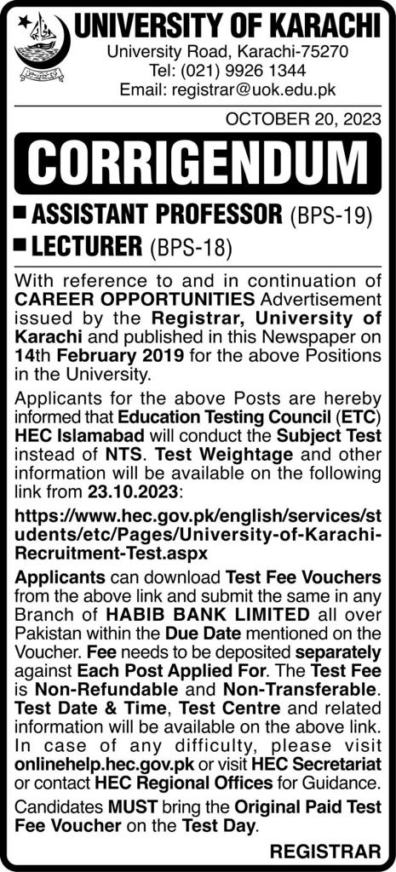
Fee Voucher's for University of Karachi Recruitment Test​​:
Fee Voucher for The Post of Assistant Professor - University of Karachi (Final Challan Asst.prof 25 NOV 2023.pdf)
Fee Voucher for The Post of Lecturer - University of Karachi​ (Final Challan Lecturer 25 NOV 2023 -.pdf)
*This is the final extension for the challan date, now extended until November 25, 2023. Thus, it represents the last opportunity to submit the fee.
​Please upload the scanned copy of the paid fee voucher using the following link: https://forms.gle/ko2CW4gGXbXtTVLfA

​Instructions to Submit the Test Fee:-
- ​Fee needs to be deposited separately​ against each post applied for.
- The test fee is non-refundable and non-transferable.

Approved Test Weightages for Lecturers and Assistant Professors University of Karachi​
Approved Test Weightages for Lecturers and Assistant Professors University of Karachi.pdf
Result and Keys
​​​​​​​​​​​​​​​​​​​​​You can check your result here and can verify it with uploaded keys.
Click here to check your result.​
HEC - Education Testing Council
ANSWER KEYS FOR THE SEE LAW TEST HELD ON JULY 14, 2024​​
F-24-1166-SEE-LAW-140724-Blue
F-24-1166-SEE-LAW-140724-Green
F-24-1166-SEE-LAW-140724-Pink
F-24-1166-SEE-LAW-140724-White
​​F-24-1166-SEE-LAW-140724-Yellow​
ANSWER KEYS FOR USAT SIX CATEGORIES HELD ON JULY 14, 2024
Click to see USAT Answer Keys ​​
Test Calendar
​Click Here to View Calendar​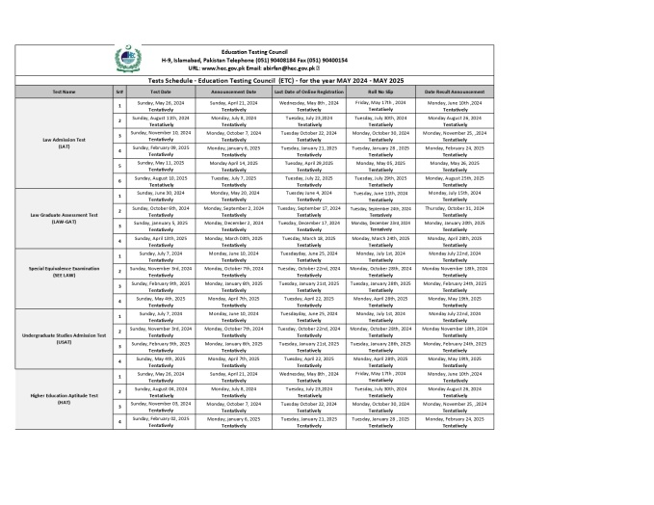​

Important Downloads
​​​​​1.Instructions for Candidate (Quality Assurance Agency Quality Assurance Agency)
2.Content Weightages for Global Institute, Lahore (CW-GIL.pdf)
3.LAT Test Pattern and Syllabus (LAT-pattern.PNG (464×262))
4. Curriculum of law GAT (Curriculum-LAW-GAT-test.pdf)
5.LAW GAT Sample Paper​ (LAW GAT Sample Paper.pdf)
6.ETC Registration User Guide (How to register for Entry Test of ETC.pdf)
7.List of Public and Private Sector Universities (Private-Public-Universities-ETC.pdf)
8.Frequently Ask Questions​ (FAQs.pdf)
Quality Assurance Agency
​​​​​​​​With the vision "To promote, enhance and assure the quality of higher education across HEIs in Pakistan" Quality Assurance Agency (QAA) was established in 2005 by the Government of Pakistan through Higher Education Commission (HEC).
QAA is a policy making and monitoring organization for enhancement and assurance of quality in Higher Education Institutions. It is involved in systematic implementation of quality enhancement procedures/criteria to attain improved levels of international compatibility and competitiveness at institutional and program level.
HEC is providing funding and logistical support for making QAA fully functional. QAA manages the affairs in collaboration with the Quality Assurance Division of HEC whereas the Quality Assurance Committee (QAC), comprising of eminent educationists, serves as its Advisory board. QAA is working to safeguard public interest by enforcing good practices in education and encouraging continuous improvement in quality in higher education.​
Our Goals:
​
- ​​​Policy making and development of practical guidelines of quality assurance related to the higher degree programs.
- Developing guidelines for establishment of Quality Enhancement Cells and their Monitoring & Evaluation.
- Capacity building to enhance the standard of quality assurance in higher education at national level.
- To monitor and regulate HEIs for implementation of policies to improve quality and standard of higher education in Pakistan.​
​
​​Our Functions:
- ​Developing practical guidelines and policies for establishing Quality Enhancement Cells at pu​blic sector universities for integration of quality assurance in the higher education system.
- Monitoring, Evaluation and Capacity Building of all Quality Enhancement Cells.
- Capacity building of selected professional staff of Quality Enhancement Cells to serve as Master Trainers after receiving training in quality assurance, to increase the levels of international compatibility through skill enhancement in the respective field.
- Hiring the services of local as well as foreign experts, having practical exposure of academic quality assurance for conducting trainings/workshops/seminars for the capacity building of QAA & QEC staff.
Draft Revamped QA Framework (PSG-2023)
​​​Please download and read the doucments of Revised QA Framework (given below) and provide your feedback on the Survey Form
Click here for Survey Form ​​
Feedback Survey: Draft Pakistan Precepts Standards & Guidelines for QA in HE (PSG-2023) (Page 1 of 6)
Introduction: The Draft Revamped Quality Assurance (QA) Framework, a collaborative effort between QAA UK and QAA Pakistan. This framework, developed through extensive consultations with key stakeholders such as Vice-Chancellors, Faculty, Directors of Quality Enhancement Cells (QECs), and Students from 22 diverse Public and Private Universities across different regions and institutional types, addresses both global best practices and local contextual challenges.
The framework not only integrates international QA standards but also incorporates localized solutions to address unique challenges faced by higher education institutions in Pakistan. By contextualizing global best practices within the local landscape, the framework offers tailored solutions that cater to the specific needs and nuances of the Pakistani higher education sector. This approach fosters a dynamic quality assurance mechanism that not only adheres to international benchmarks but also navigates through regional intricacies. The collective insights garnered from extensive consultations have played a crucial role in bridging the gap between global ideals and local realities. As a result, the Draft Revamped QA Framework embodies a holistic approach that aligns international benchmarks with the diverse challenges faced by Pakistani universities. This comprehensive framework underscores the commitment to continuous improvement and the pursuit of excellence in higher education, ultimately contributing to the enhancement of quality and accountability across the sector.
​Draft Revamped QA Framework (PSG-2023) Documents for download:
- Final Executive Summary of Revised PSG-2023 .05.pdf
(PSG-2023, QA Framework)
- Pakistan Precepts, Standards, and Guideline for Quality Assurance in Higher Education (PSG-2023) (Draft Policy: Pakistan Precepts, Standards and Guidelines for Quality Assurance in Higher Education)
- REQAAB: Reviewing Effectiveness of Quality Assurance and Accreditation Bodies. (Reviewing the Effectiveness of Quality Assurance and Accreditation Bodies (REQAAB))
- RIPE: Review of Institutional Performance & Enhancement
( A Handbook for Internal and External Quality Assurance at the Institutional Level)
- ​PREE: Program Review for Effectiveness and Enhancement
(A Handbook for Internal and External Quality Assurance at Programme Level)
Quality in COVID-19 Situation
​​​As we are all facing very challenging times relating to COVID-19. As a facilitator, HEC-QAA has our learners and trainers well-being as our primary focus. We have been constantly reviewing the advice and guidance ​from the Government of Pakistan as well as the World Health Organisation (WHO). With that in mind, we are taking the opportunity to guide Higher Education Institutions (HEIs) to launch their "Virtual Learning" system, therefore, mitigating the need for our learners to attend the classroom physically. Virtual Learning can be undertaken in the office and at home. HEC has issued Guidance for HEIs, faculty, staff, teaching, Government directions and online readiness concerning COVID-19. Guidelines can be found here.( English Covid-19 Guidance)
It is very important to ensure the quality of teaching and learning when many universities have started online classes through different Learning Management Systems. QAA is evolving and installing different checks so that requirements of continuous learning system can be assured in basic, effective, and exemplary categories.​
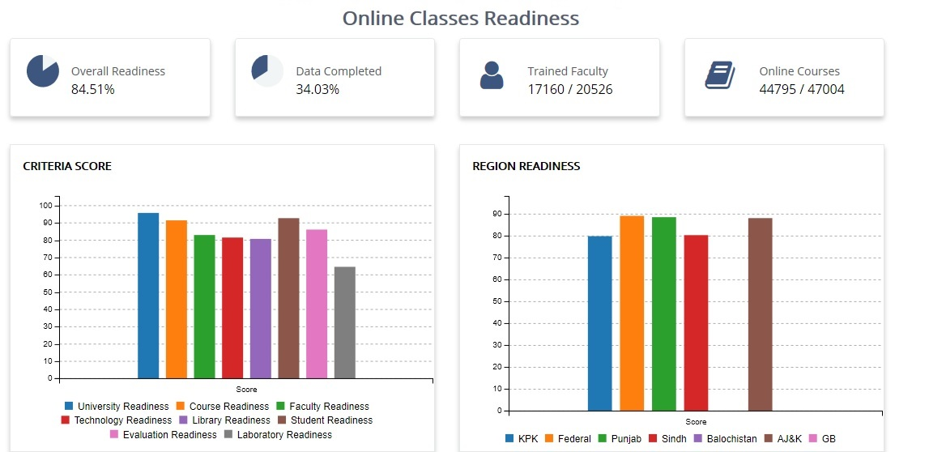
Important Documents:​
Online Readiness Guidelines have been developed and circulated to HEIs.( Establishment of OACs.pdf)
Tutorial for Online Readiness Assessment Pro-forma (Online Compliance Readiness Assessment- Tutorial - HEI University Side.pdf)
Covid-19 Guidance
- Covid-19 Guidance No.8 - ​Further Guidance for HEIs (10)
- Covid-19 Guidance No.7 – Reopening of HEIs (Microsoft Word - Gradual_Reopening-Version-4 (August 31, 2020).docx)
- Covid-19 Guidance No. 6b- O&A-Level Admissions (OandA-Level-Admissions.pdf)
- Covid-19 Guidance No. 6a- PhD-MPhil-MS Defense & Final Juries (HEC Covid-19 Policy Guidance No. 6a (PhD/MPhil/MS Defense & Final Juries))
- Covid-19 Guidance No.6 - Assessments & Examinations (Assessments-Examinations.pdf)
- Covid-19 Guidance No.5 - Online Readiness (final and assented version) (Covid-19-Policy-Guidance-No.5-Online Readiness.pdf)
- Covid-19 Guidance No.4 - Government Directive of 26 March 2020 (Government-Directive.pdf)
- Covid-19 Guidance No.3 - TSC- Final Approved Working Paper (COVID 19 – Technology support committee)
- Covid-19 Guidance No.2 - Guidelines for Faculty and Staff of the Universities DAIs (Guidelines-Faculty.pdf)
- Covid-19 Guidance No.1 - HEC Policy Guidelines for Universities and DAIs on COVID-19 (HEC-Policy-Guidelines-Universities-DAIs.pdf)
Accreditation Councils
​​​​​​​The objective of this section is to assure that all the undergrad-level programs of HEIs are accredited by their respective accreditation council. For this purpose, the section administers the activities in respect of establishing new accreditation councils and coordinating with existing councils, assessing their performance, and build their capacity.
Existing Accreditation Councils/Professional Bodies:
- Pakistan Bar Council (PBC) (Pakistan Bar Council)
- Pakistan Council for Architects and Town Planners (PCATP) (PCATP)
- Pakistan Medical & Dental Council (PMDC) (Pakistan Medical and Dental Council - Home)
- Pakistan Engineering Council (PEC) (Pakistan Engineering Council - PEC)
- Pakistan Nursing Council (PNC) (PNMC – Pakistan Nursing & Midwifery Council)
- Pakistan Pharmacy Council (PCP) (Pharmacy Council of Pakistan)
- Pakistan Veterinary Medical Council (PVMC)
- National Council for Homoeopathy (NCH) (National Council for Homoeopathy, Pakistan)
- National Council for Tibb (NCT)​ (National Council For Tibb)
- Allied Health Professionals​​
​Accreditation Councils Established by HEC:
​
- National Accreditation Council for Teachers Education (NACTE) (Home - National Accreditation Council for Teacher Education)
- National Agricultural Education Accreditation Council (NAEAC) (National Agriculture Education Accreditation Council - Home Page)
- National Computing Education Accreditation Council (NCEAC)
- National Business Education Accreditation Council (NBEAC) (Home | NBEAC)
- National Technology Council (NTC)​​ (National Technology Council)

Quality Enhancement Cells in HEIs
​​​​Quality Assurance in education plays a pivotal role in ensuring the consistent delivery of high-quality education and fostering continuous improvement in academic institutions. The Quality Assurance Agency (QAA) is committed to elevating the standard of education by implementing a comprehensive strategy across various areas.
Establishment of Quality Enhancement Cells:
The QAA recognizes that Quality Enhancement Cells are fundamental in promoting a culture of quality assurance and continuous improvement in educational institutions. QAA's initiative involves the establishment of QECs in all degree-awarding institutions and their Affiliated Colleges (QECACs). These cells serve as central units responsible for monitoring and enhancing the quality of education by developing and implementing quality assurance policies, procedures, and practices. By instating QECs, institutions are better equipped to identify areas for improvement and implement measures to enhance the overall learning experience.
Strengthening QEC Functioning:
To ensure the effectiveness of QECs, the QAA employs several strategies aimed at enhancing their functioning:
- Progress Review Meetings: Regular progress review meetings are conducted to evaluate the performance of QECs. These meetings facilitate open discussions about challenges, successes, and best practices, fostering a collaborative environment for improvement.
- Capacity Building of QECs: The QAA invests in enhancing the capabilities of QEC members through workshops, training sessions, and skill development programs. By equipping QECs with up-to-date knowledge and skills, institutions can effectively implement quality assurance measures.
- Annual Targets: QAA collaborates with institutions to set annual targets for QECs based on revised criteria. These targets are aligned with the institution's overall quality enhancement goals and serve as benchmarks for progress. This structured approach ensures that institutions are continually working towards improving various aspects of education.
Annual Assessment of QECs:
QAA's commitment to quality assurance involves conducting rigorous assessments of QECs' performance against the assigned annual targets. These assessments aim to evaluate the effectiveness of QECs in driving quality enhancement initiatives. The evaluation process involves reviewing documentation, analyzing data, and conducting site visits to gain comprehensive insights into each institution's progress. The results of these assessments guide institutions in refining their quality assurance strategies.
The Quality Assurance Agency's multi-pronged approach to quality enhancement in education demonstrates its dedication to fostering a culture of continuous improvement. By establishing QECs, strengthening their functioning through regular progress reviews and capacity building, and conducting thorough annual performance assessments, the QAA ensures that degree awarding institutions are consistently moving towards higher standards of education quality. This comprehensive strategy contributes to the overall development of a skilled and competitive workforce, better-preparing individuals for the challenges of the modern world.
List of Established QECs
- List of QECs​ (List of QECs.pdf)
Downloads:
Assessment Criteria
- Revised Cri​teria for Assessment of QECs (1-Revised Criteria for Assessment of QECs.pdf)
Targets for QECs
- SAR Target Policy 2024-25.xlsx
- Targets for QECs for the assessment year 2024-25.pdf (Targets for QECs for the assessment year 2024-25.pdf)
Yearly Progress Report Proformas
- DB. No. - Uni. Name- 2023-24-YPR.xlsx
- Main or Sub Ca​mpus (Name of Campus)
- Affiliated Institution-Name No. of affiliated institution as mentioned in YPR parameter 5.9​
- YPR Checklist
Institutional Performance Evaluation
- ​ ​
- ​The Higher Education Commission is systematically implementing the five-year (2002 -2007) agenda for reforms outlined in the HEC Medium Term Development Framework (MTDF). The key components identified in the MTDF are Access, Quality and Relevance.
- To address these challenges, a comprehensive strategy was outlined that identified the core strategic aims for reform as i) Faculty Development, ii) Improving Access, iii) Excellence in Learning and Research, and iv) Relevance to National Priorities.
- In order to improve the performance of HEIs, HEC has started with primary step of outlining the Performance Evaluation Standards for the HEIs to be used for the purpose.
- A total of eleven standards are defined in this document and all the eleven standards are equally important to be met by the HEIs to achieve the desired certification to quality provision in higher education, international visibility and significant place in the regional and international rankings of the HEIs. IPE Manual for Universities can be found here.​​( Standards for ACCREDITATION OF Higher Education Institutions)
- Various performance evaluation standards outlining major areas to be focused on by the HEIs for evaluation of their effectiveness and future development are given below:
- Standard 1: ​ Mission Statement and Goals
- Standard 2: Planning and Evaluation
- Standard 3: Organization and Governance
- Standard 4: Integrity
- Standard 5: Faculty
- Standard 6: Students
- Standard 7: Institutional Resources
- Standard 8: Academic Programmes and Curricula
- Standard 9: Public Disclosure and Transparency
- Standard 10: Assessment & Quality Assurance
- Standard 11: Student Support Service​
- ​Downloads:
- ​​TORs for Reviewers - 2021.pdf (6-IPE TORs for Reviewers - 2021.pdf)
- Compliance Implementation Plan Committee Template.pdf (UET Lahore IPE Report with cover letter.pdf)
- Data Checklist for IPE Reiew - 2021.pdf (Data Checklist for IPE Reiew - 2021.pdf)
- Expectations and Outcome Indicators - EOI. 2.0.pdf (Quality Assurance Agency, Pakistan)
- Format and Sample IPE Report 4.0.docx
- IPE Activity Schedule.pdf (IPE Activity Schedule.pdf)
- IPE Manual for Universities 11.pdf (Standards for ACCREDITATION OF Higher Education Institutions)
MS/MPhil & PhD Programs Review
​​
​As decided by the Commission in 9th meeting held on 26 November 2005. The quality of Masters and PhD (level 7 & 8 programs) are peer reviewed keeping in view the minimum criteria of HEC in order to enhance their quality to make them internationally compatible.
So far, the programs of approximately 170 universities/ HEIs/campuses have been reviewed.
Pro-formas for Program Review.
- Forms in Document (*.doc) Format​
- Form 1: Program Summary
- Form 2: Program Detailed Information
- Form 3: Program Faculty Information (For MS)
- Form 4: Program Faculty Information (For PhD)
- Form 5: Student Information (MS equivalent)
- Form 6: Student Information (PhD)​
- Form 6A: Graduate​d Student Information (MS)
- Form 6B: Graduated Student Infor​mation (PhD)​​
Forms (template) for Compliance of Program Review.
- All Forms in Zip Archive.
​- Individual Forms in Document (*.doc) format
- Form 1
- Form 2
- Form 2.0
- Form 2.1
- Form 2.2
- Form 2.3
- Form 2.4
- Form 2.5
- Form 2.6
- Form 2.7​
​ Contact Us
Quality Assurance,
Higher Education Commission (HEC),
1st Floor, HRD Building, Sector H-8,
​Islamabad, Pakistan
​Voice: +92 51 90802700
Facsimile: +92 51 90802702

Notification
​1.Decision of BOG Regarding Classified Items/Data Bank of ETC (Minutes BoG -2.pdf)
2.Notification of BOG Regarding Classified Items/Data Bank of ETC (CamScanner 10-04-2023 10.36)
3.Notification for Enhancement of Number of Law-GAT Chances​ (Final Notification HEC-ETC Law-GAT 7 Chances.pdf)
4.Notification of BOG Approved Examination Rules ETC HEC​ (Notification of BOG Approved Examination Rules _ETC HEC.pdf)
5.SOPs of Use of Unfair Means and Penalty​​ (Annex-I_ Use of Unfair Means & Panelty_Ver-1.0.pdf)
6. LAT notification (LAT notification _page-0001.jpg (2480×3508))

